**Date:** 1st June 2022

**Notice**

It is our pleasure to inform all Faculty members and students that M.K. College of Education will be conducting a Value-Added Course on "Yoga and Meditation". Faculty members and students interested in joining the course are requested to contact the course coordinator.

**Course details**

Title: Yoga and Meditation

Duration: 30 Hours

Commencement Date: 13th June 2022

Mode: Offline

**Yoga and Meditation**

**Course Duration: 30 Hours**

**Program Learning Outcome**

The program aims to enable the pre service teachers to learn practice yoga and meditation in their daily lives.

**Course Learning Outcomes:**

Learners will be able to

1. Explain the philosophical principles of yoga.
2. Perform Pranayama and Breath Control exercises
3. Learn and practice a variety of yoga poses (asanas).
4. Analyze the role of breath in meditation.

**Course Content**

**Unit 1 Introduction to Yoga Philosophy (5 hours)**

Concept of yoga, Origin and history of yoga, rules and regulations to be followed by the practitioner; core philosophies of classical yoga, including Patanjali's Yoga Sutras, yogic principles in modern life, yogic loosening practices and Surya Namaskar.

**Unit II Pranayama and Breath Control (10 hours)**

Pranayama and its significance in yogic practices, ranayama techniques, such as Ujjayi, Nadi Shodhana, and Kapalabhati, connection between breath, energy, and emotions

**Unit III Different positions and Asanas (10 hours)**

Demonstration, Explanation and practice of Tadasana, Demonstration, Explanation and practice of Vrikshasana, Demonstration, Explanation and practice of Trikonasana, Demonstration, Explanation and practice of Virabhadraasana, Demonstration, Explanation and practice of Balasana, Demonstration, Explanation and practice of Shavasana.

**Unit IV Meditation (5 hours)**

Meaning, origin and history of meditation, development, physical, emotional and spiritual benefits, meditation techniques, including concentration, mindfulness, and mantra meditation, meditation and its effects on the brain.

**Evaluation Criteria**

At the end of the course, students will demonstrate the asanas in front of the expert and share origin, precautions and benefits of the asanas

**Mode of Classes**

The Course will be conducted through offline mode in the college campus.

**Cost**

The course is free of cost

**Important dates**

|  |  |
| --- | --- |
| Registration starts | 2nd June 2022 |
| Registration starts | 11th June 2022 |
| Start of Course | 13th June 2022 |
| Final test | 27th July 2022 |

**Brochure**

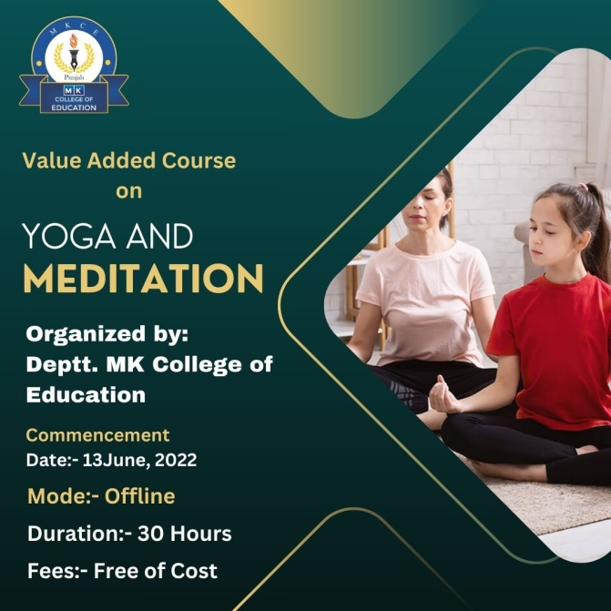

**Classes**

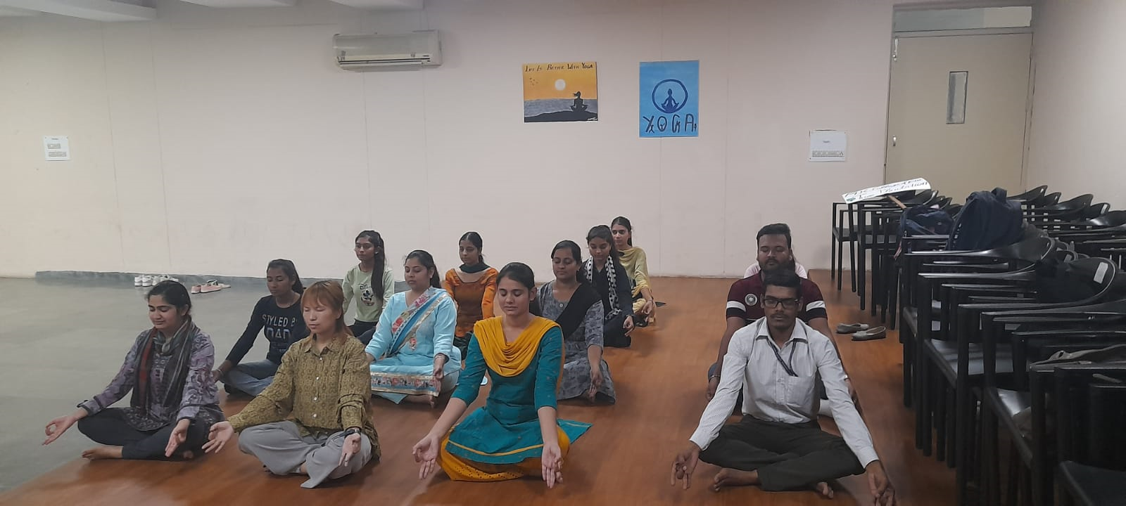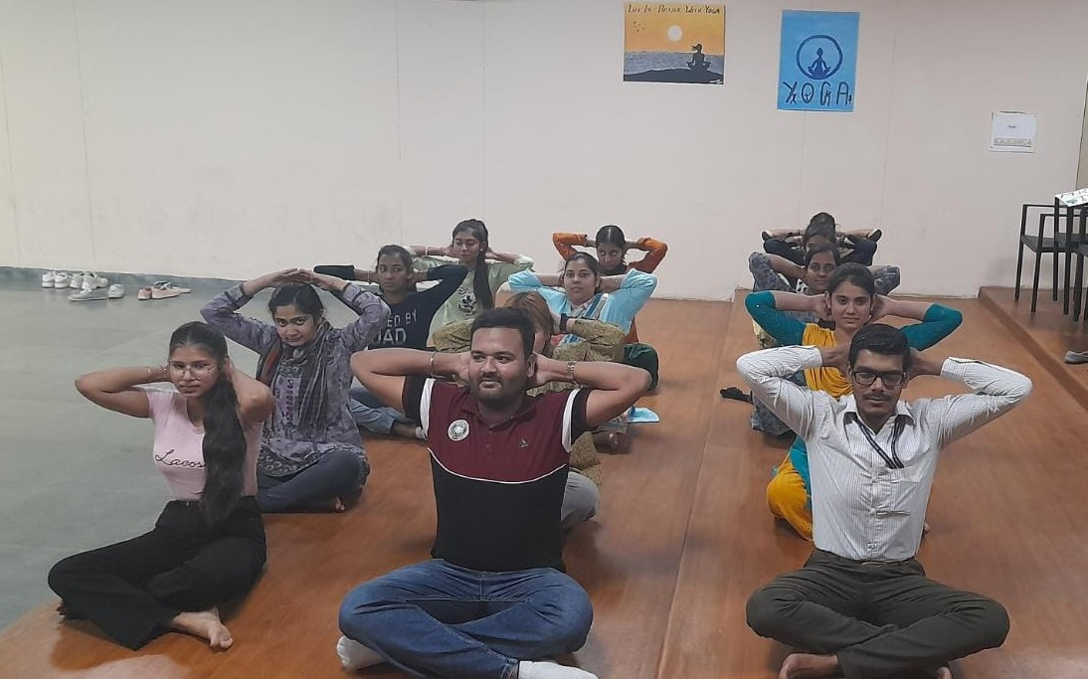

**List of Students enrolled in Value Added Course “Yoga and Meditation”**

|  |  |  |  |
| --- | --- | --- | --- |
| **S.No.** | **Name of the Student** | **Programme** | **Year** |
| 1 | Manju | B.Ed. | 2022 |
| 2 | Kabeera ram | B.Ed. | 2022 |
| 3 | Joti | B.Ed. | 2022 |
| 4 | Sandeep kaur | B.Ed. | 2022 |
| 5 | Baljit kaur | B.Ed. | 2022 |
| 6 | Rajwinder | B.Ed. | 2022 |
| 7 | Sapna | B.Ed. | 2022 |
| 8 | Jaswinder kaur | B.Ed. | 2022 |
| 9 | Ravi Kiran | B.Ed. | 2022 |
| 10 | Rajwinder kaur | B.Ed. | 2022 |
| 11 | Gurpreet Kaur | B.Ed. | 2022 |
| 12 | Palvi sharma | B.Ed. | 2022 |
| 13 | Namrata | B.Ed. | 2022 |
| 14 | Diana | D.El.Ed. | 2022 |
| 15 | Vanshika | D.El.Ed. | 2022 |
| 16 | Anchal | D.El.Ed. | 2022 |
| 17 | Mamta | D.El.Ed. | 2022 |
| 18 | Alka thaper | D.El.Ed. | 2022 |
| 19 | Taniya ladhar | D.El.Ed. | 2022 |

**Course completion certificates**

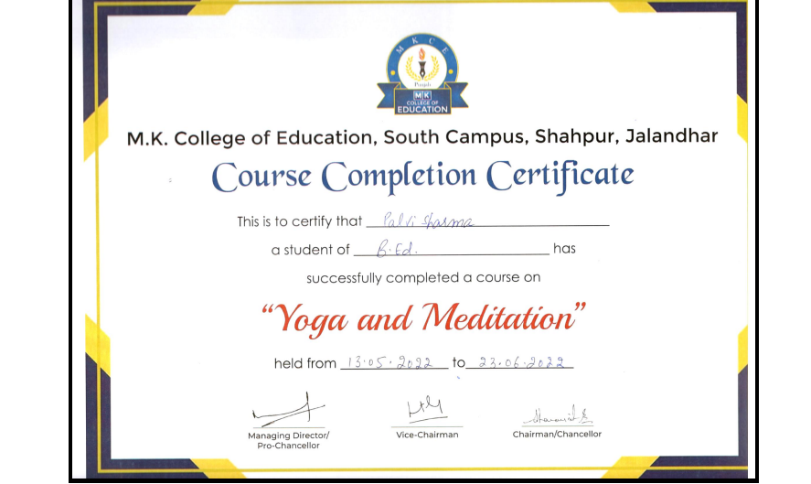

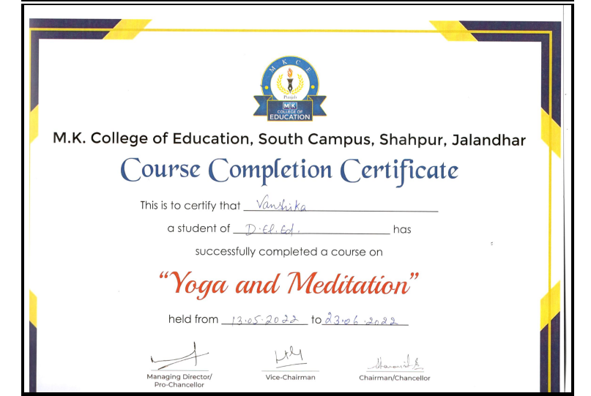

**Feedback from students**

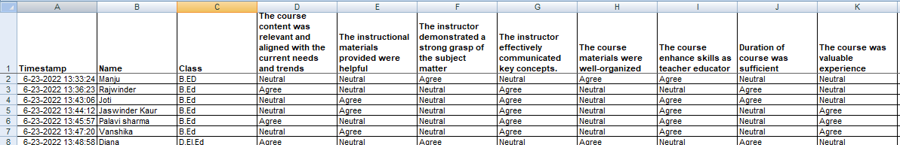

**Date:** 28th July 2022

**Notice**

It is our pleasure to inform all Faculty members and students that M.K. College of Education will be conducting a Value-Added Course on "Workshop on Model Making." Faculty members and students interested in joining the course are requested to contact the course coordinator.

**Course details**

Title: Workshop on Model Making

Duration: 30 Hours

Commencement Date: 8th August 2022

Mode: Offline

**Workshop on Model making**

**Course Duration: 30 Hours**

**Program Learning Outcome**

The program aims to enable the pre service teachers to learn how to create and incorporate models for effective teaching learning process

**Course Learning Outcomes:**

Learners will be able to

1. Identify different types of educational models and their applications in the teaching process.
2. Develop hands-on skills in creating effective educational models suitable for various subjects and grade levels.
3. Analyze and apply design principles for developing engaging and instructive educational models.
4. Integrate model making into lesson planning to enhance teaching effectiveness and student engagement.
5. Gain confidence in utilizing model making as a dynamic and interactive teaching method for pre-service teachers.

**Course Content**

**UNIT 1**

**Introduction to Model Making in Education (6 hours)**

Concept and types models; Importance and role of model making in effective teaching and learning; need for pre-service teachers to be engaged in model making; Practical applications of model making in the classroom

**UNIT 2**

**Developing and Integrating Models in Teaching (15 hours)**

Exploration of various educational models; Key principles for designing effective educational models; Practical demonstration of model making techniques; Guidance on selecting appropriate materials; Hands-on activities to identify and create simple models

**UNIT 3**

**Integrating Models into Lesson Planning (9 hours)**

Strategies for incorporating models into lesson plans; Collaborative session on developing lesson plans with models; Methods for assessing student understanding using models

**Evaluation Criteria**

At the end of the course, students need to submit one model from their both pedagogies. In Addition students will teach in the class by using the models.

**Mode of Classes**

The Course will be conducted through offline mode in college art room.

**Cost**

The course is free of cost

**Important dates**

|  |  |
| --- | --- |
| Registration starts | 29th July 2022 |
| Registration ends | 4th August 2022 |
| Start of Course | 8th August 2022 |
| Final test | 26th September 2022 |

**Brochure**

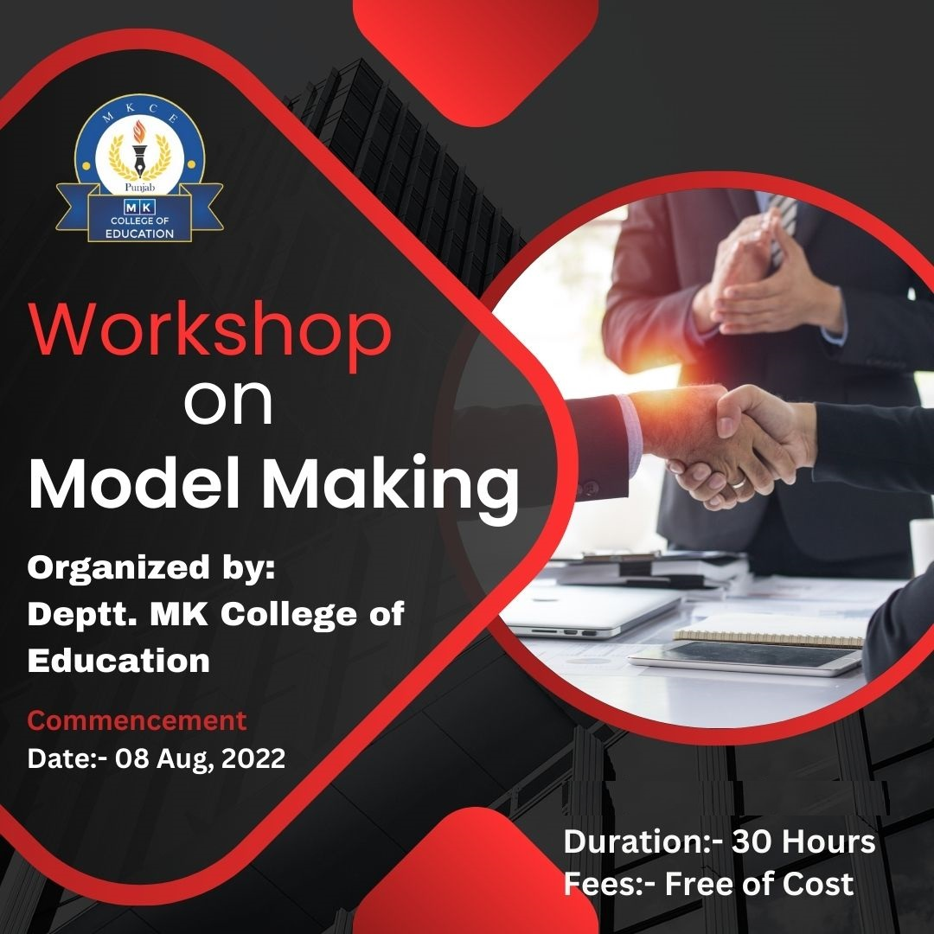

**Classes**

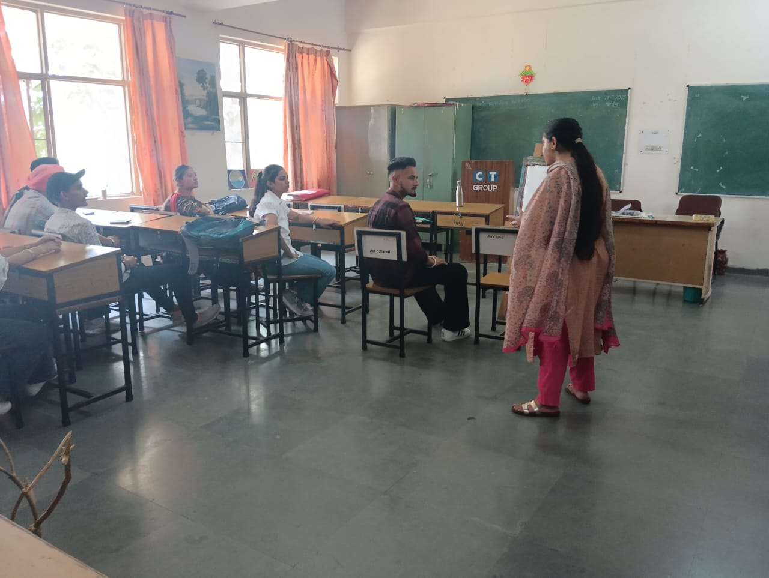 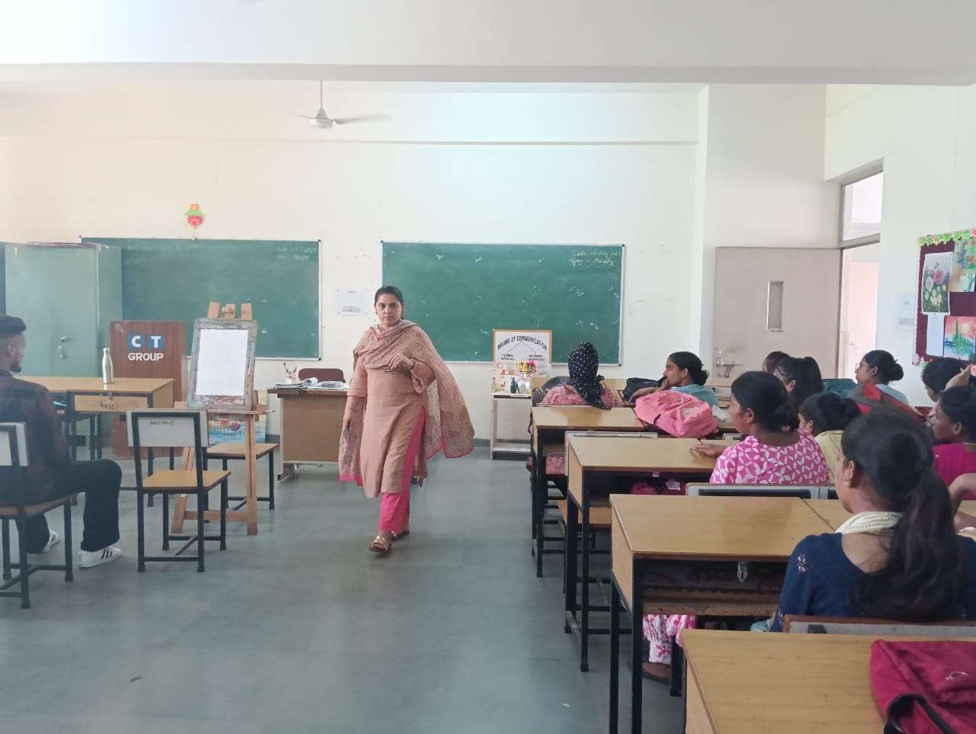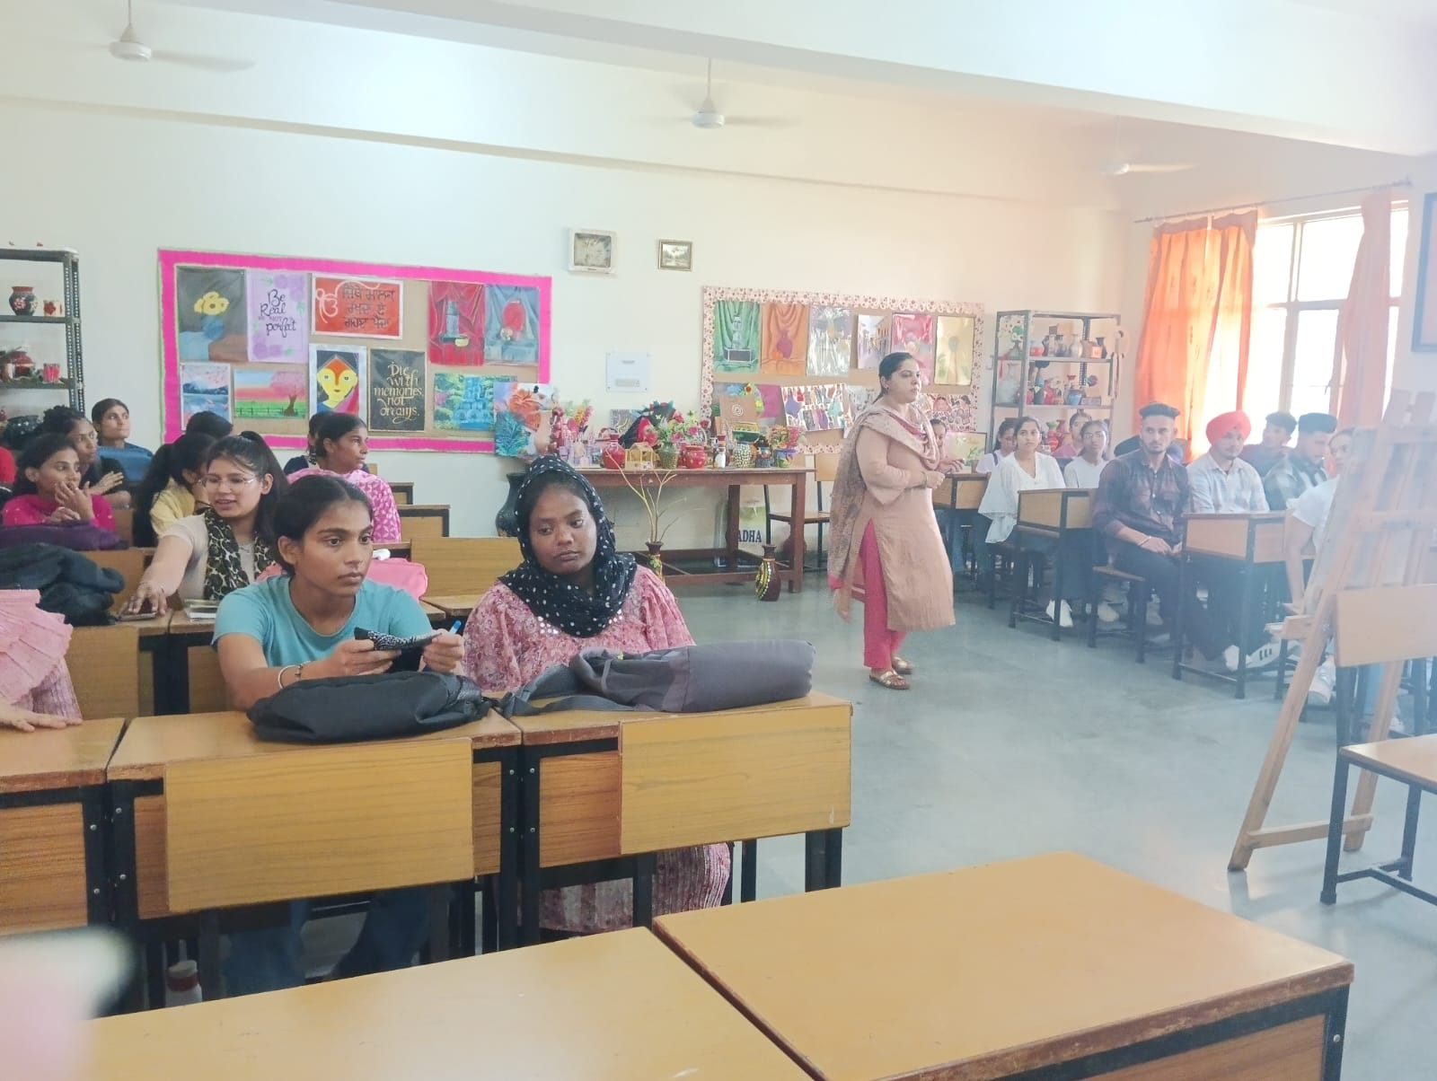

**List of Students enrolled in Value Added Course “Workshop on Model Making”**

|  |  |  |  |
| --- | --- | --- | --- |
| **S.No.** | **Name of the Student** | **Programme** | **Year** |
| 1 | Samta | D.El.Ed. | 2022 |
| 2 | Neha | D.El.Ed. | 2022 |
| 3 | Kailash | D.El.Ed. | 2022 |
| 4 | Sonali | D.El.Ed. | 2022 |
| 5 | Nisha | D.El.Ed. | 2022 |
| 6 | Veena Rani | D.El.Ed. | 2022 |
| 7 | Som Veer | D.El.Ed. | 2022 |
| 8 | Palak | D.El.Ed. | 2022 |
| 9 | Ajnesh Kumar | D.El.Ed. | 2022 |
| 10 | Sakshi | D.El.Ed. | 2022 |
| 11 | Divya | D.El.Ed. | 2022 |
| 12 | Kulwinder | D.El.Ed. | 2022 |
| 13 | Parveen Kumar | D.El.Ed. | 2022 |
| 14 | Vikas Kumar | D.El.Ed. | 2022 |
| 15 | Varkha | D.El.Ed. | 2022 |
| 16 | Suman | D.El.Ed. | 2022 |
| 17 | Chander Mohan | D.El.Ed. | 2022 |
| 18 | Kushlya Devi | D.El.Ed. | 2022 |
| 19 | Sajan Kumar | D.El.Ed. | 2022 |
| 20 | Mangaldeep | B.Ed. | 2022 |
| 21 | Rajni Sharma | B.Ed. | 2022 |
| 22 | Santokh Singh | B.Ed. | 2022 |
| 23 | Pardum Kumar | B.Ed. | 2022 |
| 24 | Bhuvnesh Kumar | B.Ed. | 2022 |
| 25 | Sampa Saha | B.Ed. | 2022 |
| 26 | Kabeera Ram | B.Ed. | 2022 |
| 27 | Anjali Kataria | B.Ed. | 2022 |
| 28 | Baljinder Singh | B.Ed. | 2022 |
| 29 | Joti | B.Ed. | 2022 |
| 30 | Sandeep Kaur | B.Ed. | 2022 |
| 31 | Rajwinder Kaur | B.Ed. | 2022 |
| 32 | Amit Kumar | B.Ed. | 2022 |
| 33 | Dinesh Rai | B.Ed. | 2022 |

**Course completion certificates**

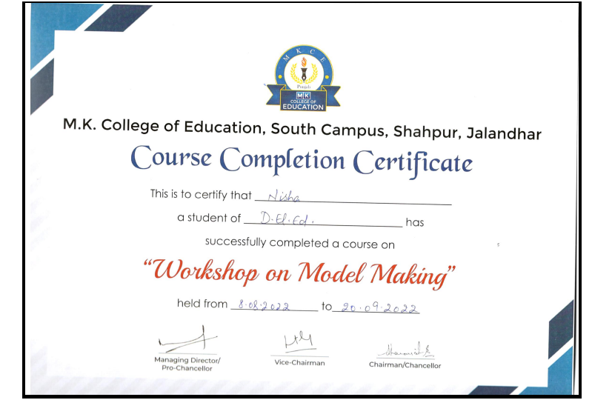

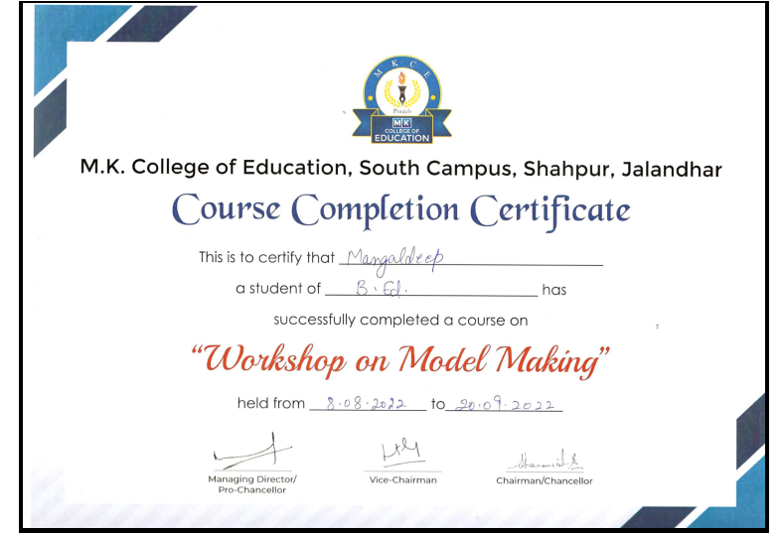

**Feedback from students**

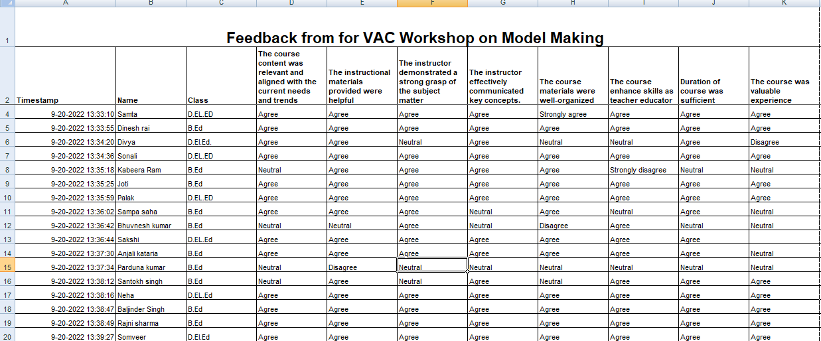

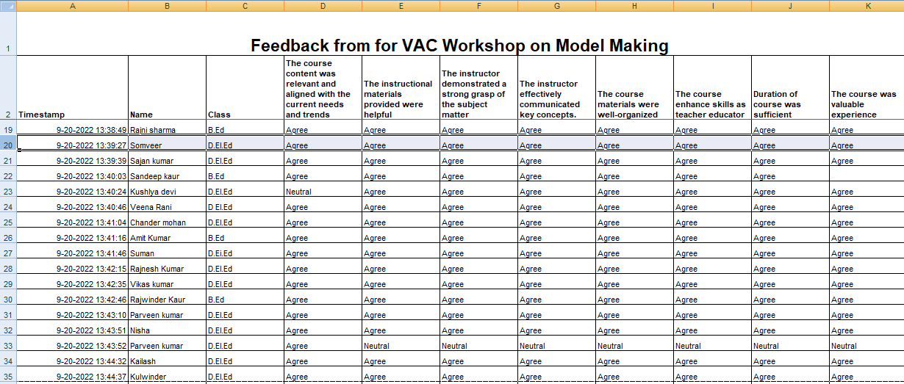

**Date:** 18th March 2023

**Notice**

It is our pleasure to inform all Faculty members and students that M.K. College of Education will be conducting a Value-Added Course on "Logical Reasoning". Faculty members and students interested in joining the course are requested to contact the course coordinator.

**Course details**

Title: Logical Reasoning

Duration: 30 Hours

Commencement Date: 3rd April 2023

Mode: Offline

**Logical reasoning**

**Course Duration: 30 Hours**

**Program Learning Outcome**

The program aims to equip the pre service teachers with the essential skills and techniques necessary for effective logical thinking.

**Course Learning Outcomes:**

Learners will be able to

1. Analyze the importance of logical reasoning in everyday life.
2. Solve the question of number and alphabet series
3. Use the logics to answer blood relations

**Course Content**

Unit 1: Calendar , Odd One Out , Analogy Figure Counting ,Missing Numbers

Unit 2: Number Series, Alphabet Series, Direction Sense

Unit 3: Blood Relation, Cubes and Dices, Coding Decoding, Clocks

Unit 4: Inequality, Ranking , Test , Syllogism Venn Diagram , Sitting Arrangement

**Evaluation Criteria**

At the end of the course, a test will be conducted for evaluation. The test will consist of 20 objective type questions carrying 2 marks for each question. It is compulsory to score 40% marks in the final test to earn a certificate of successfully completing the course.

**Mode of Classes**

The Course will be conducted through offline mode.

**Cost**

The course is free of cost

**Important dates**

|  |  |
| --- | --- |
| Registration starts | 20th March 2023 |
| Registration ends | 31st March 2023 |
| Start of Course | 3rd April 2023 |
| Final test | 19th May 2023 |

**Brochure**

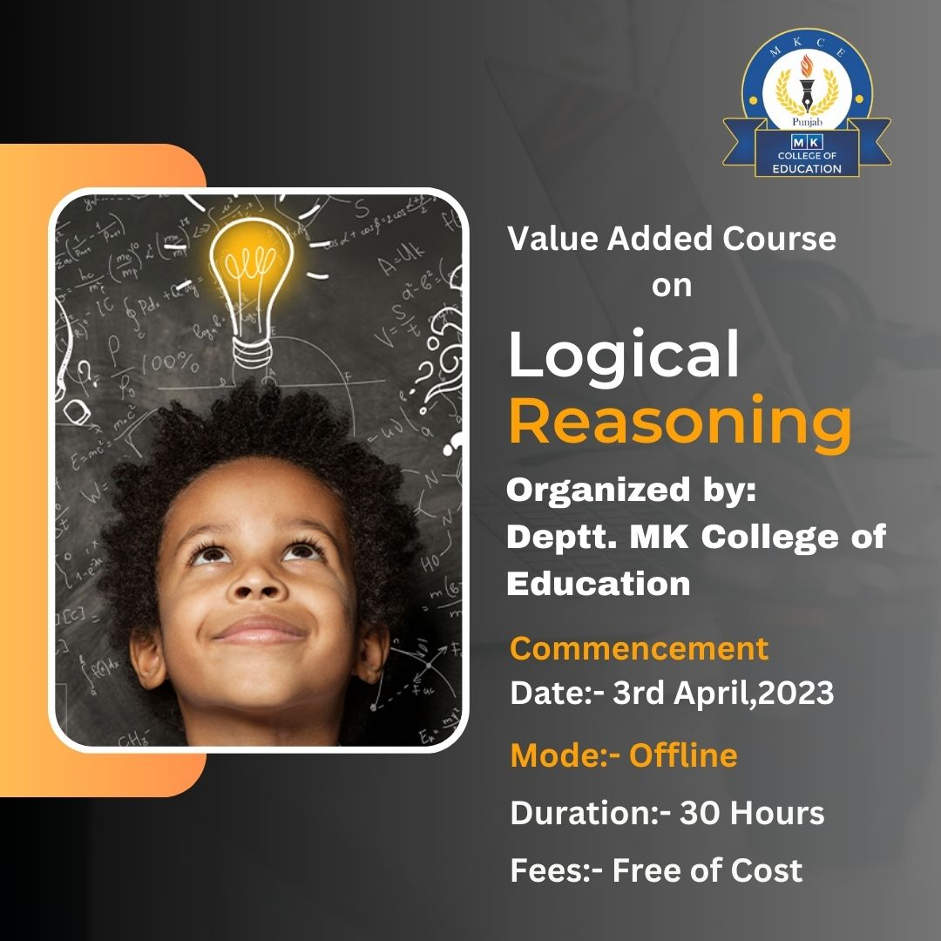

**Classes**

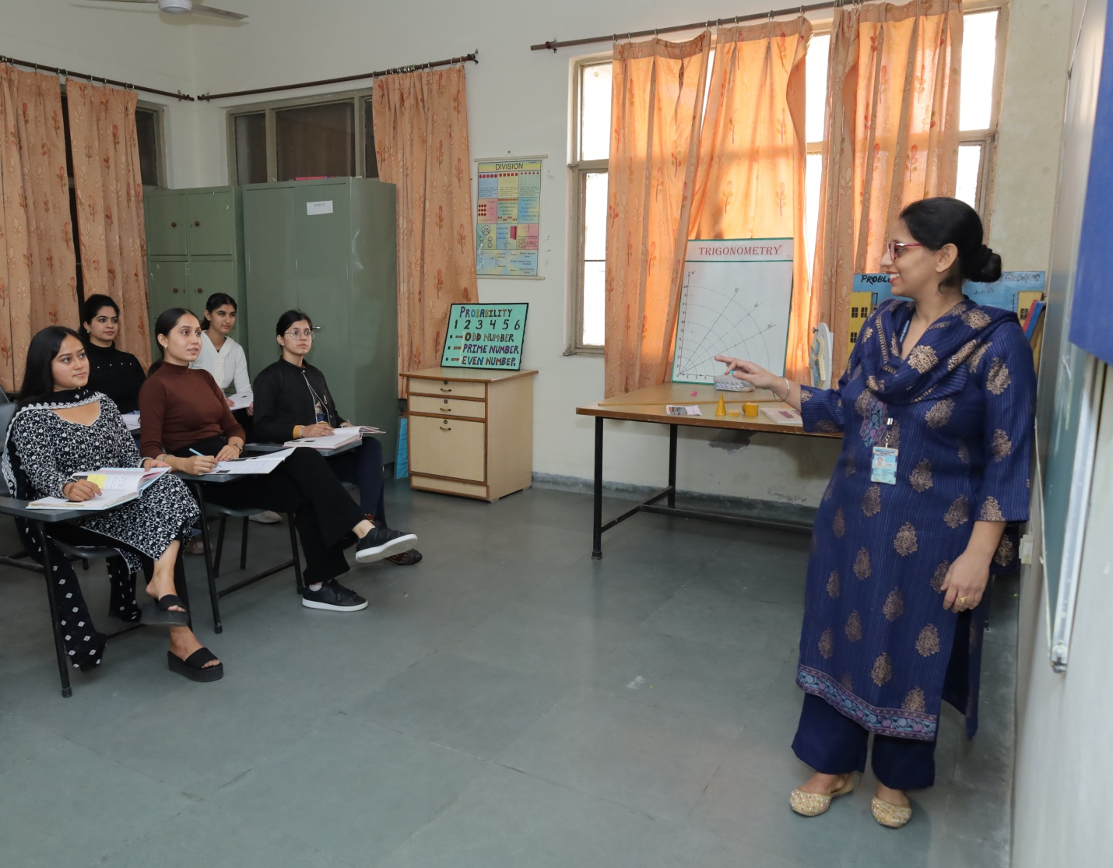

**List of Students enrolled in Value Added Course “Logical Reasoning”**

|  |  |  |  |
| --- | --- | --- | --- |
| **S.No.** | **Name of the Student** | **Programme** | **Year** |
| 1 | Priya | D.El.Ed. | 2023 |
| 2 | Amrit | D.El.Ed. | 2023 |
| 3 | Harpreet Kaur | D.El.Ed. | 2023 |
| 4 | Minakshi | D.El.Ed. | 2023 |
| 5 | Mamta Sabherwal | D.El.Ed. | 2023 |
| 6 | Kulwinder Kaur | D.El.Ed. | 2023 |
| 7 | Kalpna | D.El.Ed. | 2023 |
| 8 | Daljit Kaur | D.El.Ed. | 2023 |
| 9 | Sanna | D.El.Ed. | 2023 |
| 10 | Manjinder Kaur | D.El.Ed. | 2023 |
| 11 | Mamta Kumari | B.Ed. | 2023 |
| 12 | Minakshi Devi | B.Ed. | 2023 |
| 13 | Sakshi Beri | B.Ed. | 2023 |
| 14 | Surbhi Sharma | B.Ed. | 2023 |
| 15 | Reetika Khosla | B.Ed. | 2023 |
| 16 | Priya Sharma | B.Ed. | 2023 |
| 17 | Richa Khosla | B.Ed. | 2023 |
| 18 | Suman Rani | B.Ed. | 2023 |

**Course completion certificates**

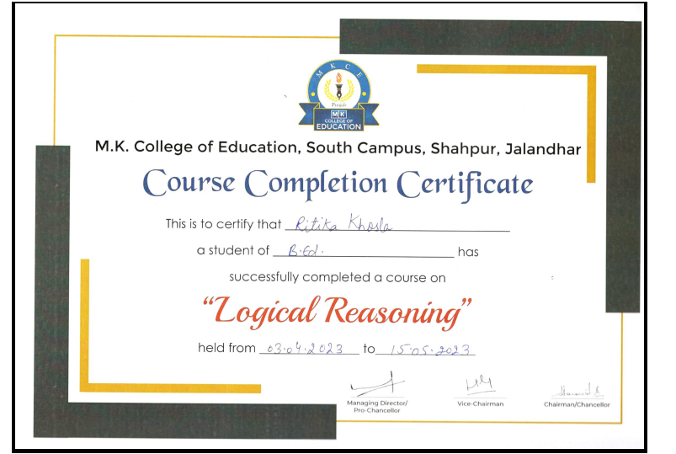

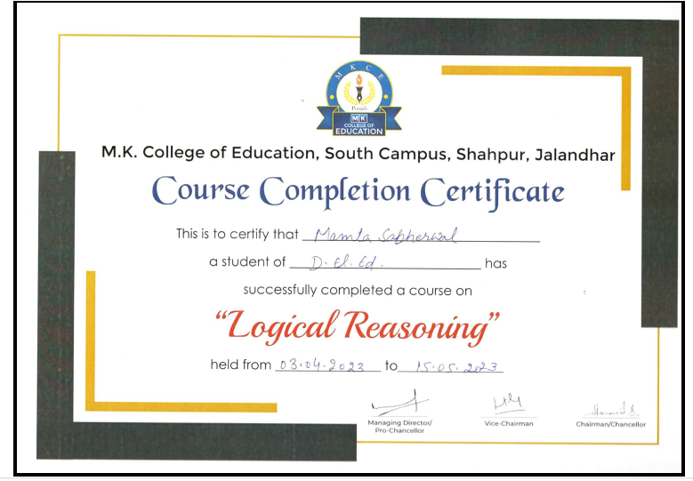

**Feedback from students**

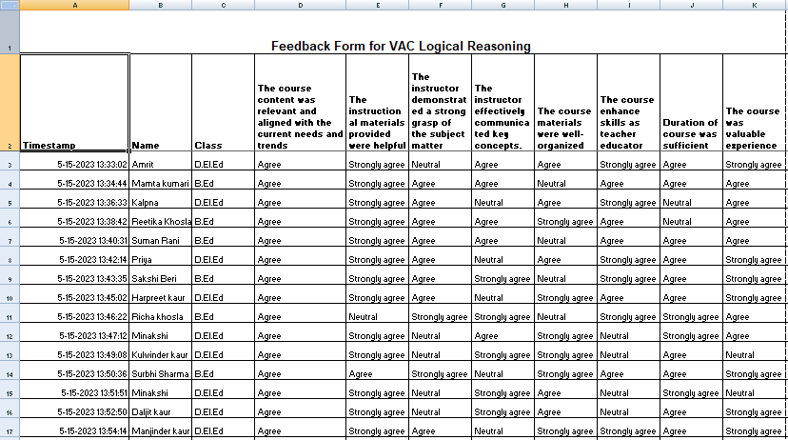

Date: 28th February 2023

**Notice**

It is our pleasure to inform all Faculty members and students that M.K. College of Education will be conducting a Value-Added Course on " Addressing the needs of Children with Special Needs" Faculty members and students interested in joining the course are requested to contact the course coordinator.

**Course details**

Title: Addressing the needs of Children with Special Needs

Duration: 30 Hours

Commencement Date: 9th March 2023

Mode: Offline

**Addressing the needs of Children with Special Needs**

**Course Duration: 30 Hours**

**Program Learning Outcome**

The program aims to enable the pre service teachers to learn practice yoga and meditation in their daily lives.

**Course Learning Outcomes:**

Learners will be able to

1. Identify the signs and symptoms of specific learning disability
2. Chalk out the remedial strategies for children with ADHD
3. Apply the remedial strategies for teaching children with intellectual disabilities
4. Explore the signs and symptoms of children with physical impairments

**Course Content**

**UNIT 1: Addressing the needs of children with Learning disability (A)**

Meaning and characteristics of learning disabilities, causes of learning disabilities, concept of specific learning disabilities, signs and symptoms of dyslexia and dyscalculia; remedial strategies for children with dyslexia and dyscalculia.

**UNIT 2: Addressing the needs of children with Learning disability (B)**

Concept, signs and symptoms of dyspraxia, processing disorders and non-verbal learning disabilities, remedial strategies for children with dyspraxia, processing disorders and non-verbal learning disabilities

**UNIT 3: Addressing the needs of children with ADHD**

Meaning and characteristics of ADHD, causes of ADHD, signs and symptoms of ADHD, remedial strategies for children with ADHD

**UNIT 4 : Addressing the needs of children with intellectual disabilities**

Concept, signs and symptoms of students with intellectual disabilities remedial strategies for children with intellectual disabilities

**UNIT 5: Addressing the needs of children with physical impairments (A)**

Concept, signs and symptoms of students with orthopedic impairment and visual impairment, identification and general classroom adaptations for students with orthopedic impairment and visual impairment

**UNIT 6: Addressing the needs of children with physical impairments (B)**

Concept, signs and symptoms of students with hearing impairment, and speech impairment, identification and general classroom adaptations for students with hearing impairment, and speech impairment

**Evaluation Criteria**

At the end of the course, a test will be conducted for evaluation. The test will consist of 25 objective type questions carrying 2 marks for each question. It is compulsory to score 40% marks in the final test to earn a certificate of successfully completing the course.

**Mode of Classes**

The Course will be conducted through offline mode.

**Cost**

The course is free of cost

**Important dates**

|  |  |
| --- | --- |
| Registration starts | 1st March 2023 |
| Registration ends | 8th March 2023 |
| Start of Course | 9th March 2023 |
| Final test | 28th April 2023 |

**Brochure**

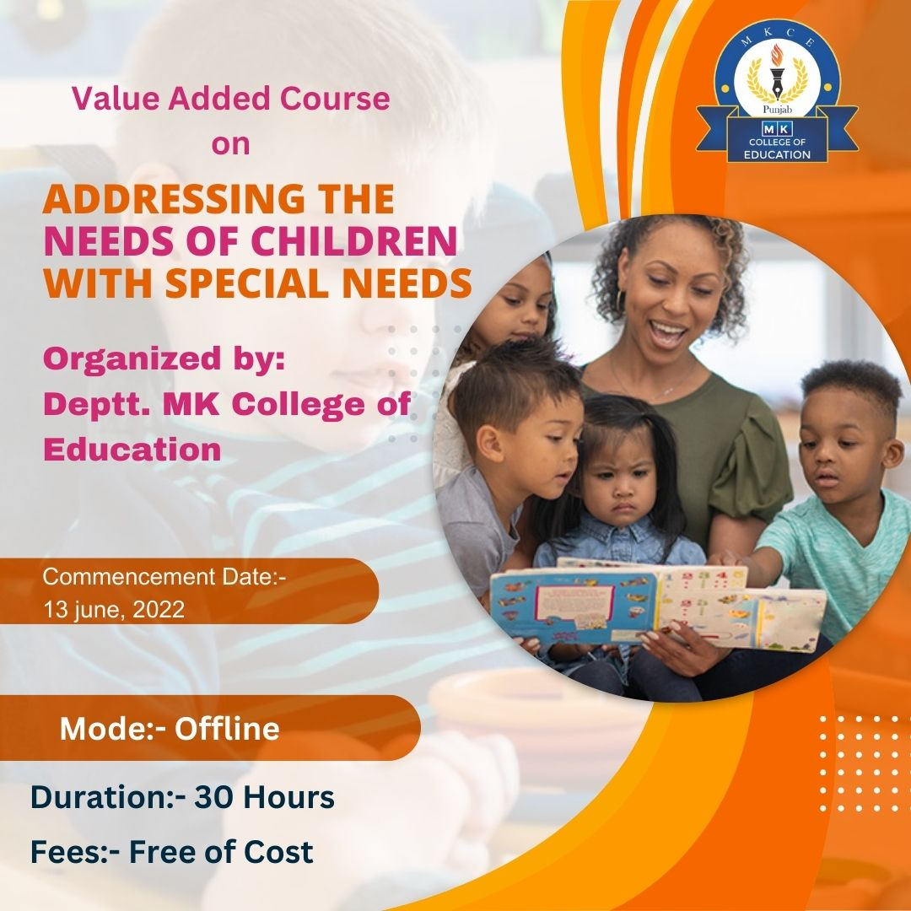

**Classes**

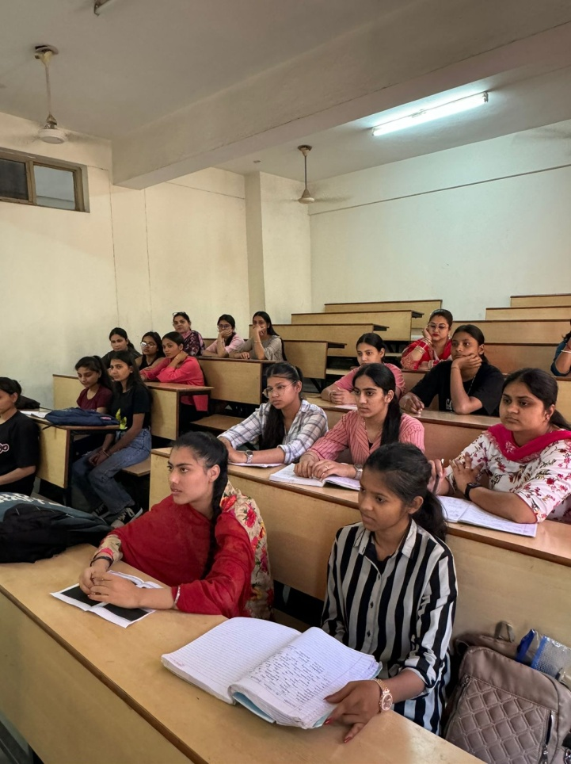 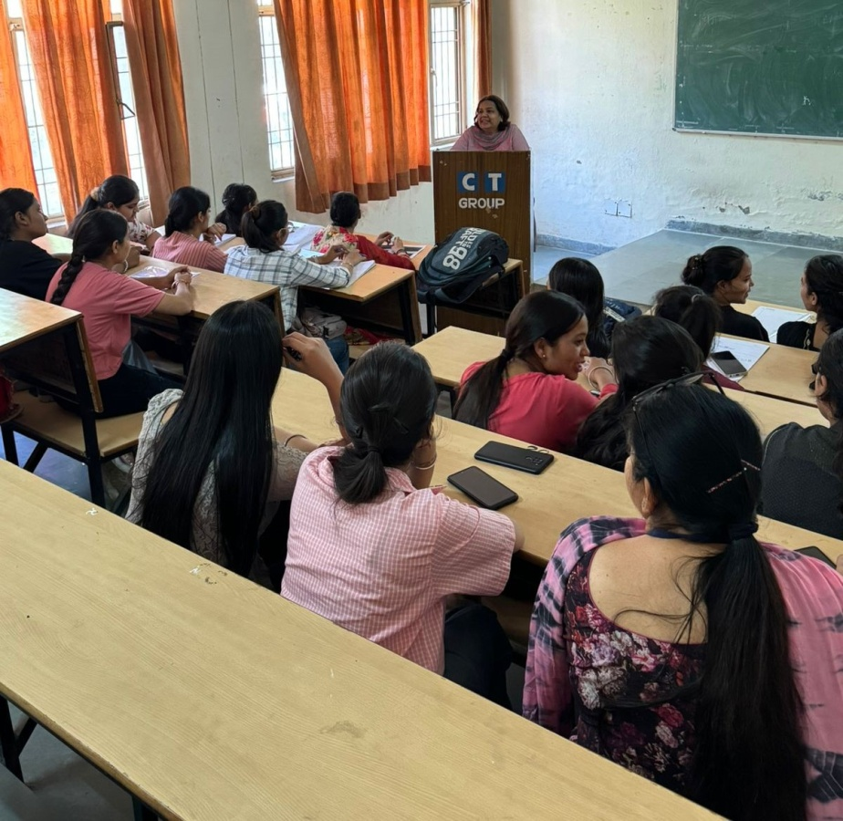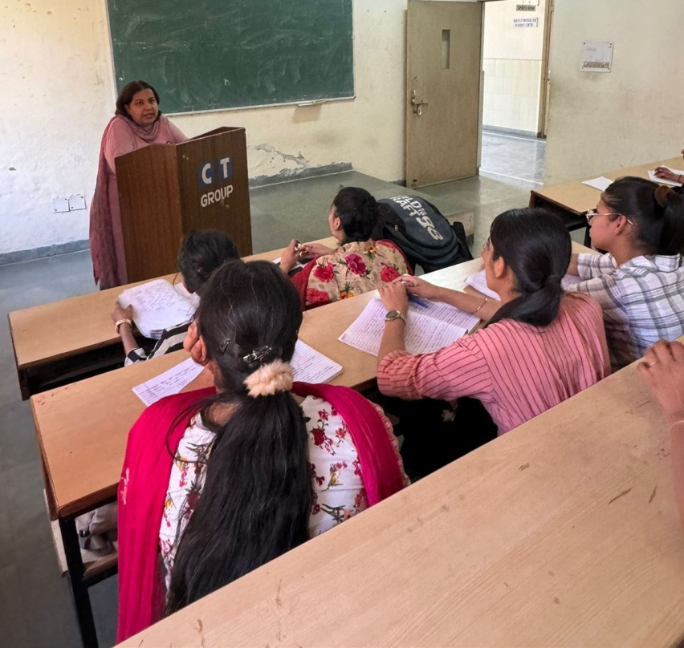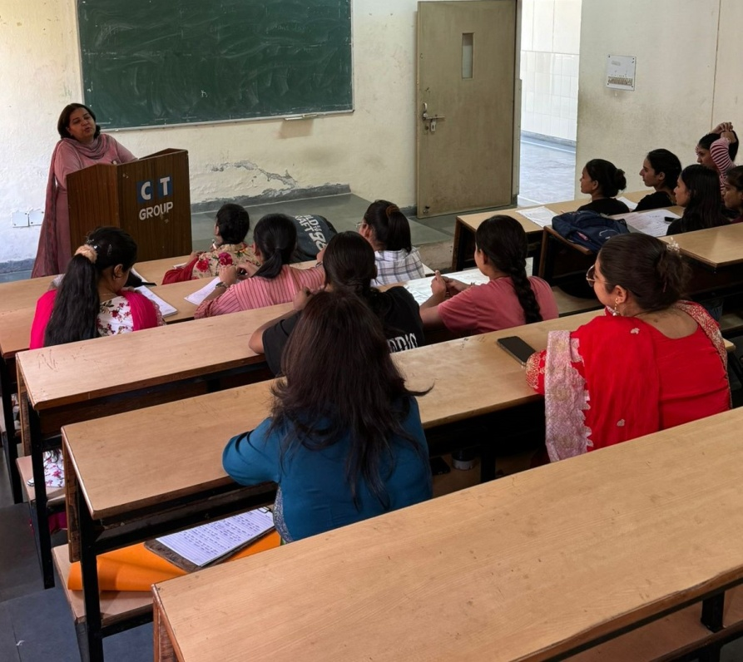

**Course completion certificates**

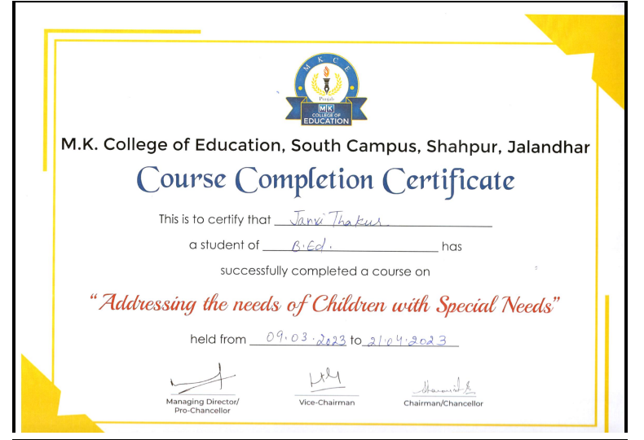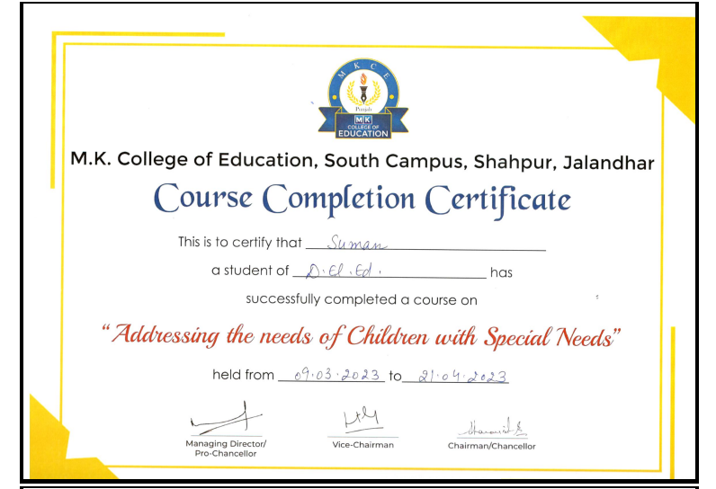

**Feedback from students**

